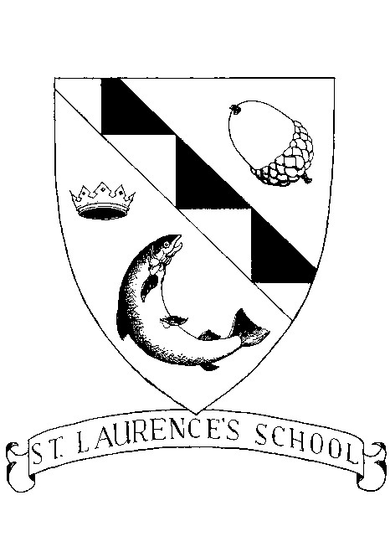

St Laurence’s National School, Chapelizod

Healthy Eating Policy

June 2016
Healthy Eating Policy

As part of the Social, Personal and Health Education (SPHE) and Physical Education Programmes, at St. Laurence’s N.S. we encourage the children to become more aware of the need for healthy food in their lunch boxes.

What people eat is known to be a key factor influencing health. Research indicates a strong link between diet and performance (e.g. a low sugar intake promotes concentration, lessens hyperactivity, protects teeth, and lessens the risk of diabetes. A low salt intake reduces the risk of heart disease in later life).

Aim:
The aim of this policy is to ensure children eat a healthy, well-balanced lunch, thus promoting a healthy lifestyle. By encouraging healthy eating patterns, we educate children for later life.

Lunch is an important meal for school-going children. It should provide one third of their recommended daily allowance of nutrients without being high in fat, sugar or salt. It should also provide dietary fibre (roughage).

The traditional packed lunch of milk and sandwiches is under attack from a range of convenience foods like crisps, sweets, biscuits, chocolate and soft drinks. Parents and teachers are concerned about this trend but some find it difficult to come up with popular healthy alternatives. We ask you to encourage a healthy lunch right from the start.

The following guide is designed to help you provide quick, appetising, and nutritious lunches for your children:

Bread & Alternatives Savouries

Bread or rolls, preferably wholemeal Lean Meat
Rice – wholegrain Chicken/Turkey
Pasta – wholegrain Tinned Fish e.g. tuna/sardines
Potato Salad Cheese
Wholemeal Scones
Bread sticks
Crackers
Pitta bread

Fruit & Vegetables Drinks

Apples, Banana, Peach Milk
Mandarins, Orange segments, Water
Fruit Salad, dried fruit, Yoghurt
Plum, Pineapple cubes
Grapes,
Cucumber, Sweet corn
Tomato

The 5 Cs are not allowed

- Candy, sweets, lollipops or jellies, etc
- Chocolate, incl biscuits, pastries, muffins, chocolate spread, cereal bars
- Chewing gum
- Crisps, incl salted nuts, popcorn or corn snacks
- Carbonated drinks, incl fizzy or fruit flavoured water, juices etc

1

So as to take a proactive approach to healthy lunches, teachers will from time to time, reward children who can show a piece of fruit or other healthy foods in their lunchboxes.

Roles and Responsibilities

Role of Parents:
- Provide a healthy well-balanced lunch for children
- Encourage healthy eating
- Inform the school of any child’s special dietary needs
- To implement school policy by not allowing their children to bring crisps, carbonated drinks, candy, chocolate or chewing gum to school

Role of Children:
- To eat their lunch
- To bring home any uneaten lunch
- To help make their lunches and remind parents of the Healthy Eating Policy
- Not to bring crisps, carbonated drinks, candy, chocolate or chewing gum to school

Role of School:
- To promote and encourage healthy eating
- To send home any foods deemed to fall under the category of the 5 Cs and provide an alternative healthy option.
- To influence behaviour on food selection and consumption and engagement in appropriate levels of physical activity through the curriculum.

Teachers will continue to give children a sweet treat on occasion. Sweet treats will be used sparingly.

2

