St. Laurence’s N.S.
School Calendar
September 2026 – June 2027

Wednesday 26th August | School re-opens for pupils
Monday 26th Oct -Friday 30th Oct | Mid-Term Break: school closed
Friday 22nd December | School closes for Christmas holidays
Wednesday 6th January | School re-opens
Monday 1st February | School closed for Bank Holiday
Mon 15th-Fri 19th Feb | Mid-Term break: school closed
Tuesday 17th March | School closed for St. Patrick’s Day
Friday 19th March | School closes for Easter holidays
Monday 5th April | School re-opens
Mon 3th May-7th May | School closed for Bank Holiday break
Mon 7th and Tues 8th June | School closed for June Bank Holiday Break
Wednesday 30th June | Last day of school year  School closes for summer holidays
12/04/2027 | Full-day school closures for staff training  Language Awareness
*Harvest Thanksgiving in St. Laurence’s Church: TBC
*Carol Service in St. Laurence’s Church: TBC
*Sports Day in Donore Harriers TBC
*End of Year Graduation Service in St. Laurence’s Church TBC
*End of year performance TBC

School begins promptly at 8.50am and ends at 1.30pm for Infants / 2.30pm for 1st Class upwards

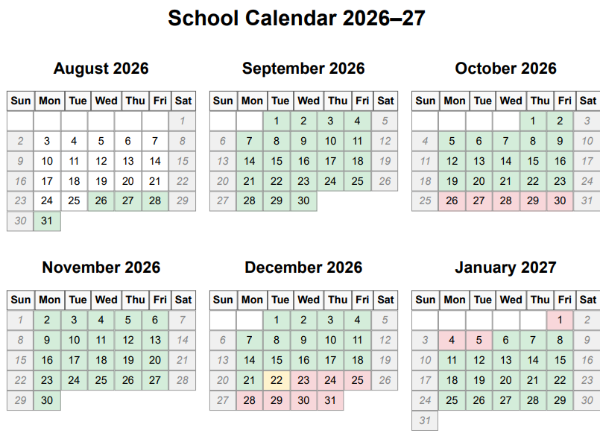
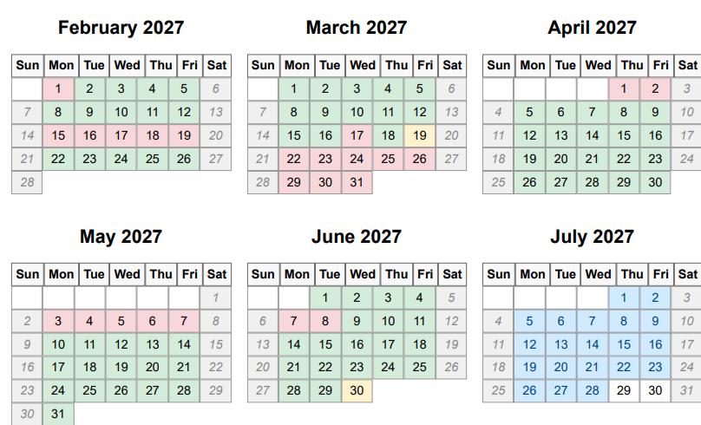
Green= school open, Red=school closed, Yellow= 12pm closure

